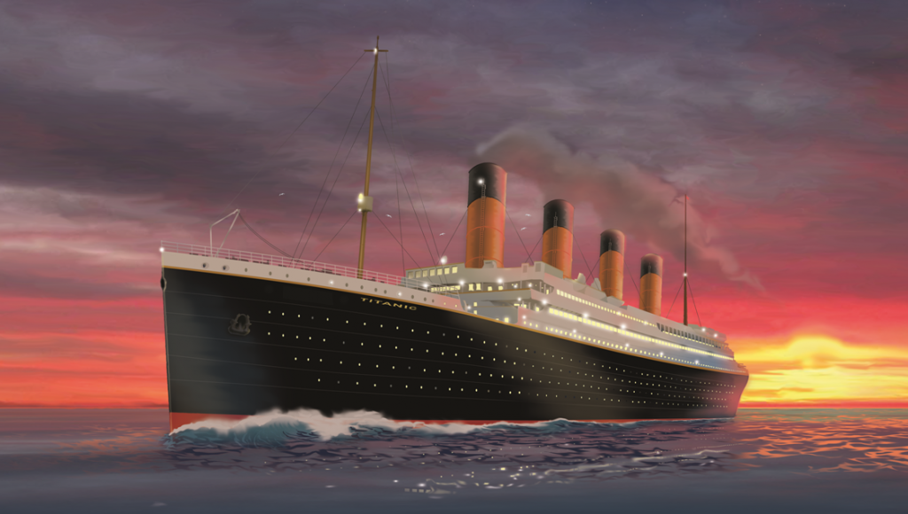

**April 10, 1912 12:00pm (noon)**

**Titanic**

**Second Floor, Suite 20**

**Unsinkable!**

April 10, 1912 12:00pm (noon)

Southampton Boarding Dock

**Titanic is Setting Sail!**

Largest most luxurious ship a float!

Second Floor, Suite 20

$70,000